**Considerations about CO2 pollution reduction by pyrometer temperature control**

**in the Aluminum Extrusion process**

The natural gas furnace for billet heating is the primary source of CO2 and CO gas production on the Aluminum extrusion production line.  
 The amount of CO2 and CO gas depends on whether natural gas is fully incinerated during heating. However, even if the technological heating process is tuned well, the burning reaction produces CO2 and CO as final products.  
So, reducing may only be heating optimization by following the technological instructions.  
A gas-heating furnace is intended to heat billets to a specific temperature required by the extrusion process according to the alloy type and profile geometry.  
Billet heating may be flat when billet temperature is equal along billet length (see Fig. 1 (a))  
In this case, a single-point thermocouple or pyrometer may perform the temperature control.  
Another way of heating is temperature tapering when the billet head is colder than the billet tail (T2-T1). This method is widely used for isothermal extrusion when the pressed profile is produced with the same temperature throughout the cycle and has the same metallurgical properties along the entire profile length.  
However, the fog thermocouple is usually well maintained for an accurate temperature readout, with the correct sharpening angle and clean tips. This is not always possible during the production process, and the thermocouple loses sensitivity and has a slower reaction.

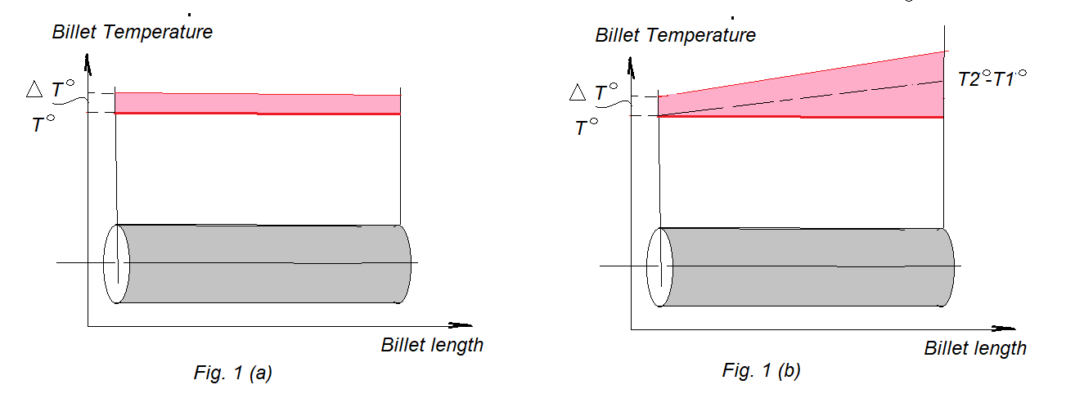

In the case of tapered billets, a line of thermocouples (5-6 pieces) was used for control, which simultaneously touched the billet to take temperature.  
Here, the extruder can get the correct temperature shape between T1 and T2, but in both cases, all measurements will be lower than the real temperature.   
For measurements, the billet should be stopped; after stopping, it immediately begins to cool down.  
And, due to thermocouple time reaction and sensitivity defects, the readout will be lower than the actual temperature for which the billet heated in the furnace – See Fig.2 (T4)  
  
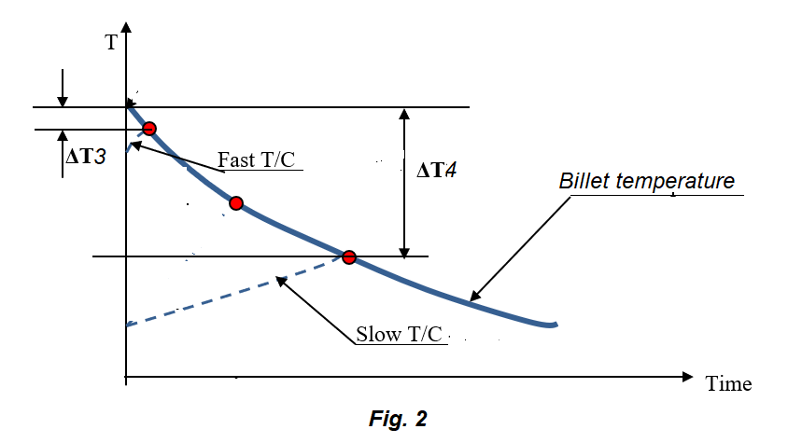

The factors mentioned above cause lower-than-real temperature readouts. Even if the extruder tries to keep the correct technological temperature and set the furnace heating, it will always be higher than necessary for ΔT, as shown in Fig.1.

This overheating causes ΔT˚ to use more gas than necessary, increasing CO2 and CO pollution.  
 When a pyrometer is used for billet temperature control, it’s free of accuracy reduction. Its reaction time is up to 0.1 seconds, which avoids inertia error during billet cooling down.